Y2Q2W7

The Fiery Furnace

Discussion at Tables:
Ask: Has anyone ever asked you to do something you know you are not allowed to do?
Ask: What did you do?

Say: Today we are learning about what happened to Daniel's friends when they were told to do something that God would not like.

Bible Story – (with white board (use orange pen for giant statue – draw small stick figures.)

Ask: Could Nebuchadnezzar change what was going to happen in the future by changing the statue from his dream?

Sing Songs Jesus loves me, I'm in the Lord's Army, Let us come together, Hallelu, My God loves me etc.

Return to tables
Memory Verse: Fill in the blanks and then say the memory verse on the colouring page and finish.

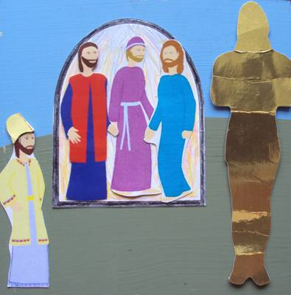
Say: This term we are going to make fridge magnets to tell the Bible stories with. You will keep your magnets in a special magnet book which we will loan to you until the end of the term and then you can take the magnets home – but we will keep the magnet books for next time. DO NOT DRAW OR WRITE ON THE MAGNET BOOKS

Magnet Books
- Hand out 3rd person magnet.
- Hand out golden statue and put a magnet on the back.
- Draw flames in the furnace, colour in and put a magnet on the back at the top.

Discuss the following depending on age, interest and time:
What things have other people told/asked/encouraged you to do that were wrong?
What things might other people tell you to do that are unwise?
What do you do when someone tells you to do something wrong?
Could Nebuchadnezzar change what was going to happen in the future?
Discuss which parts of Nebuchadnezzars dream have already come true.

Story: Great Stories for kids by Jerry D Thomas, © 1999, Pacific Press Publishing Association, "Mystery of the Missing Reindeer" – This story has good examples on how to say no when your friends try to get you to do something wrong.

Finish with prayer.

